**APPLICATION NAME:** Food-Race Application

**DESCRIPTION:** Food-Race Application is an application to automate or reduce the manpower at the reception i.e., the customer himself can select the orders from the menu and place his final order. However, this must be further integrated with Payment gateways to automate the payment process too to make sure the end-to-end process is customer friendly and is automated.

**ASSUMPTIONS:**

1. To Demonstrate the functionality, as of now, a customer can place maximum and minimum of 3 Orders which can be later picked up dynamically.
2. The Directory Location where the log file will be generated is configured to C:/Users/lokendrav/which can be either modified based on the convenience to be read from a configuration file or for instance, the path can modified in the ApplicationConstants.java file.

**CONSOLE SNAPSHOT:**

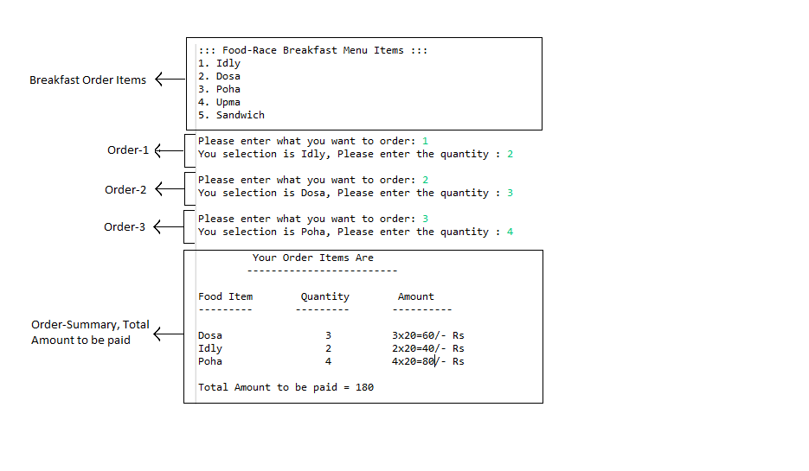

**LOG FILE SNAPSHOT:**

